SCHOOL OF NATURAL AND APPLIED SCIENCES
DEPARTMENT OF COMPUTER SCIENCE AND INFORMATION TECHNOLOGY (CSIT)
PROJECT - NPRJ740
ADVANCED ICT DIPLOMA - 2026
SUPERVISOR: DR TITE TUYIKEZE

PHASE 2
System Requirements, Modelling and Project Management

Field | Details
Name of Document | Phase 2: System Requirements, Modelling and Project Management
Project Title | AgroAdvisor: an AI-assisted farm advisory platform for smallholder farmers
Name of the System | AgroAdvisor
Student Name | [Student name]
Student Number | [Student number]
Submission Date | [Confirm submission date with the supervisor]

Yellow-highlighted text marks content that still needs a personal detail or real evidence from the student.

TABLE OF CONTENTS
1. System Functional and Non-Functional Requirements 3
1.1 Product features (functional requirements) 3
1.2 System non-functional requirements 4
2. System Modelling 4
2.1 Context diagram 4
2.2 Architectural design 5
2.3 System design models 6
3. Project Management 10
3.1 Work breakdown 10
3.2 Gantt chart 13
4. Conclusion 13

1. System Functional and Non-Functional Requirements
AgroAdvisor is built for one type of user: the smallholder farmer. There are no administrator, buyer or other roles. The system interprets weather data together with each farmer's farm profile (location, crops, livestock) to give personal advice and severe-weather warnings, instead of only showing the weather.
Priority uses the MoSCoW scale: M = Must have, S = Should have, C = Could have. Status shows what exists in the current version of the system.

1.1 Product features (functional requirements)
ID | Requirement | Priority | Status
FR1 | A farmer can register with full name, email and password, and can sign in with email and password. | M | Built
FR2 | A farmer can sign in with a Google account. A Microsoft sign-in button exists but the provider is not yet enabled in Firebase. | S | Google built; Microsoft pending
FR3 | A farmer can create and edit one farm profile: name, nearest town, location on a map, size (acres or hectares), crops and livestock with counts, and an optional photo. | M | Built
FR4 | A farmer can set the farm location by tapping a map or using the device location. | M | Built
FR5 | A farmer can estimate plot size by walking the boundary with the device GPS. GPS points are not saved. | C | Built
FR6 | A farmer can add a crop or animal by taking or choosing a photo, which the system identifies, or by typing its name. | S | Built
FR7 | The dashboard shows current weather for the farm (temperature, conditions, high and low, humidity, feels-like) next to the farm name. | M | Built
FR8 | The system shows a 7-day farm outlook with an interpretation and a risk note for each day, based on the farm's crops and livestock. | M | Built
FR9 | The system shows a severe-weather warning (heat, frost, heavy rain, strong wind, storm) with what to do, when and why, and can read the warning aloud. | M | Built
FR10 | The farm profile map shades nearby estimated temperatures (cool, mild, warm, hot). | C | Built
FR11 | A farmer can browse reviewed and published video lessons grouped by topic, with short key steps. | M | Built
FR12 | A farmer can mark a lesson complete. The completion is saved in the farm memory. | S | Built
FR13 | A farmer can record a weather event, planting or what worked, and see a weekly summary and recent entries. Entries can be removed. | S | Built
FR14 | A farmer can add a local observation (flooding, frost or other) within 25 km of their farm and see visible notes nearby on a map. | S | Built
FR15 | A farmer can report another farmer's note. A note is hidden after two different farmers report it. The author can remove their own note. | S | Built
FR16 | A farmer can change the interface language (English, Afrikaans, isiZulu, Sesotho, Setswana). | S | Built
FR17 | The system sends a background push notification when severe weather is forecast, even if the app is closed. | C | Not built: needs a service-account key

1.2 System non-functional requirements
The targets below are design targets. They have not yet been measured in a formal test, so no measured result is claimed.
ID | Quality | Requirement (design target)
NFR1 | Reliability | If the weather service or the Worker is unavailable, the dashboard shows a clear error with a retry option and does not show wrong data. Saved farm data is never changed by a failed forecast request.
NFR2 | Availability | The client (Cloudflare Pages), the Worker (Cloudflare) and the database (Firebase) are managed cloud services, so no server needs to be maintained by the farmer or the developer. Availability is therefore that of these providers.
NFR3 | Security | Every farmer can read and write only their own farmer, farm and memory data. Firestore Security Rules enforce this on the server. The Worker verifies the Firebase ID token on each request. Secrets are kept in environment files and Wrangler secrets, never in source code.
NFR4 | Security | Community notes contain no names. Direct database writes are limited by rules: note length, 25 km radius, one report per farmer per note, and report counts that cannot be forged. Six automated rule tests cover these cases.
NFR5 | Maintainability | TypeScript strict mode with no 'any'. Firestore access only through service modules. All agronomic thresholds live in one knowledge-base file with a comment explaining each rule. The worker uses one shared response helper.
NFR6 | Portability | The client is a web application that runs in any modern browser on phone or computer. No app-store installation is needed.
NFR7 | Performance | The interface is mobile-first and the build is split into smaller files so the first screen loads quickly on slow mobile data. The map is loaded only when needed. Target: the dashboard shows weather soon after the forecast response arrives. [Measure and record load times before submission.]
NFR8 | Usability | Plain-language advice, large touch targets (buttons at least 44 px high), labelled form controls, sufficient colour contrast and a loading, empty and error state on every data screen.
NFR9 | Cost | The system stays on free plans: Firebase Spark, Cloudflare free tier and Open-Meteo. No Cloud Functions are used.

2. System Modelling

2.1 Context diagram
The context diagram shows AgroAdvisor as one process, the farmer as the only user, and the external systems it exchanges data with.
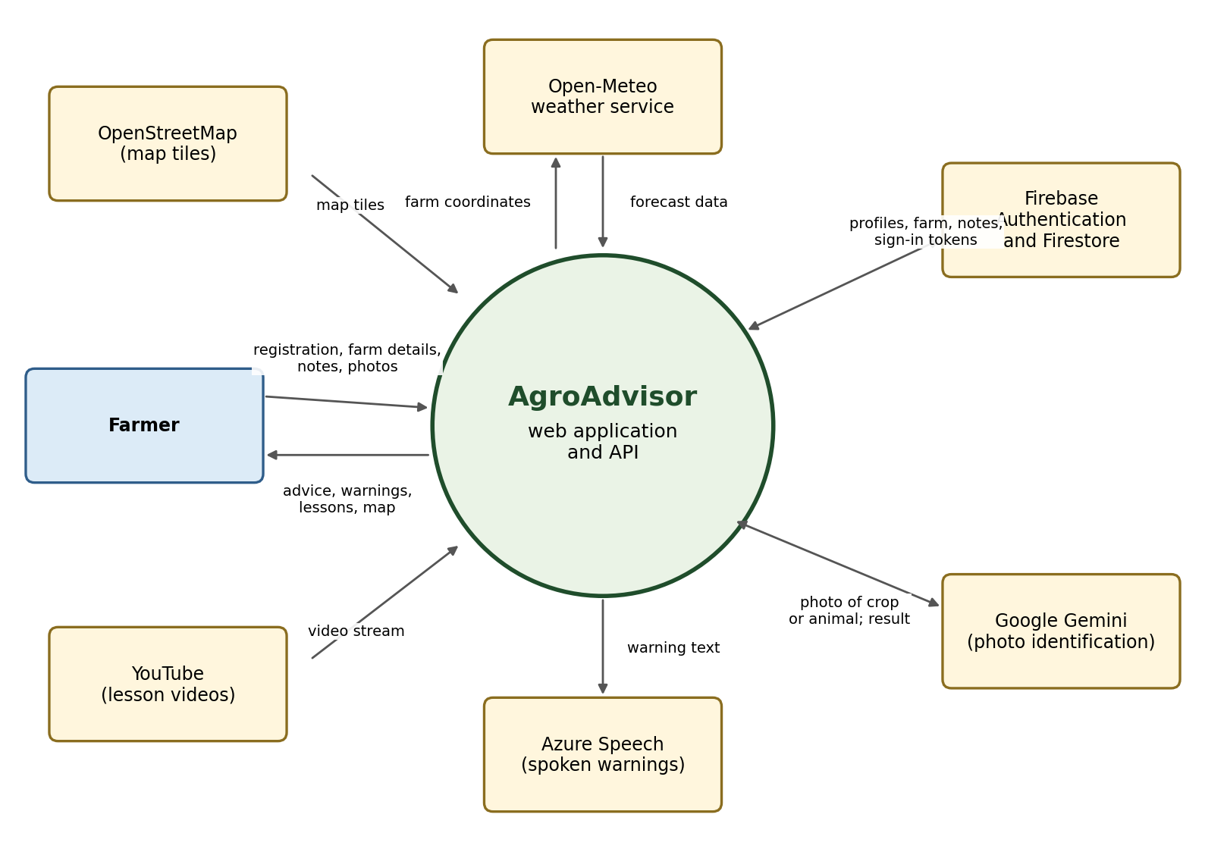
Figure 1: Context diagram of AgroAdvisor

2.2 Architectural design
AgroAdvisor uses a client-server model organised in three layers.
Layer | Components | Responsibility
Presentation | React + TypeScript + Tailwind client on Cloudflare Pages: pages, components, service modules, weather-advice rules | Shows screens, collects input, reads and writes the farmer's own Firestore data through service modules, and turns forecast data into advice and warnings using the knowledge-base thresholds.
Application | Hono API on a Cloudflare Worker: authentication middleware, routes under /api (health, weather, vision, speech), forecast and regional-grid services | Verifies the Firebase ID token with the jose library, reads the farm profile with the farmer's own token, fetches forecasts, identifies photos and creates speech. Every response uses the shape {success, data, message}.
Data and external services | Firebase Authentication, Cloud Firestore with Security Rules, Open-Meteo, Google Gemini, Azure Speech, YouTube, OpenStreetMap | Stores accounts and data, enforces who may read or write each document, and supplies weather, image analysis, speech, video and map tiles.

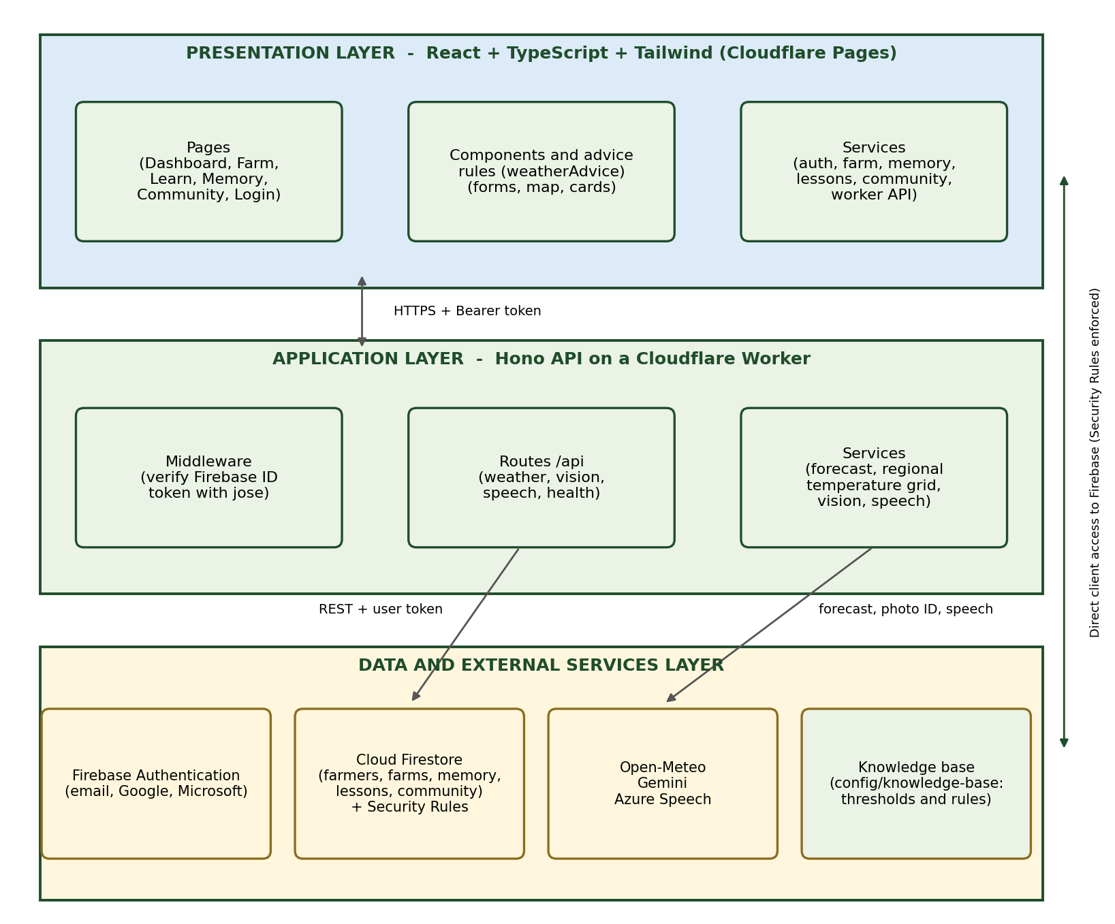
Figure 2: Three-layer architecture
Key design decisions:
- The client reads and writes Firestore directly, so Security Rules are the real permission check, not client-side code.
- The Worker uses the farmer's own ID token when it reads the farm profile, so the same rules still apply.
- Thresholds (for example heat at 35 °C or more, frost at 2 °C or less) are stored in the knowledge-base file and not inside components.

2.3 System design models

2.3.1 Use case diagram
The use cases below extend the Phase 1 diagram with photo identification (UC11) and plot measurement (UC12), which were added during development.
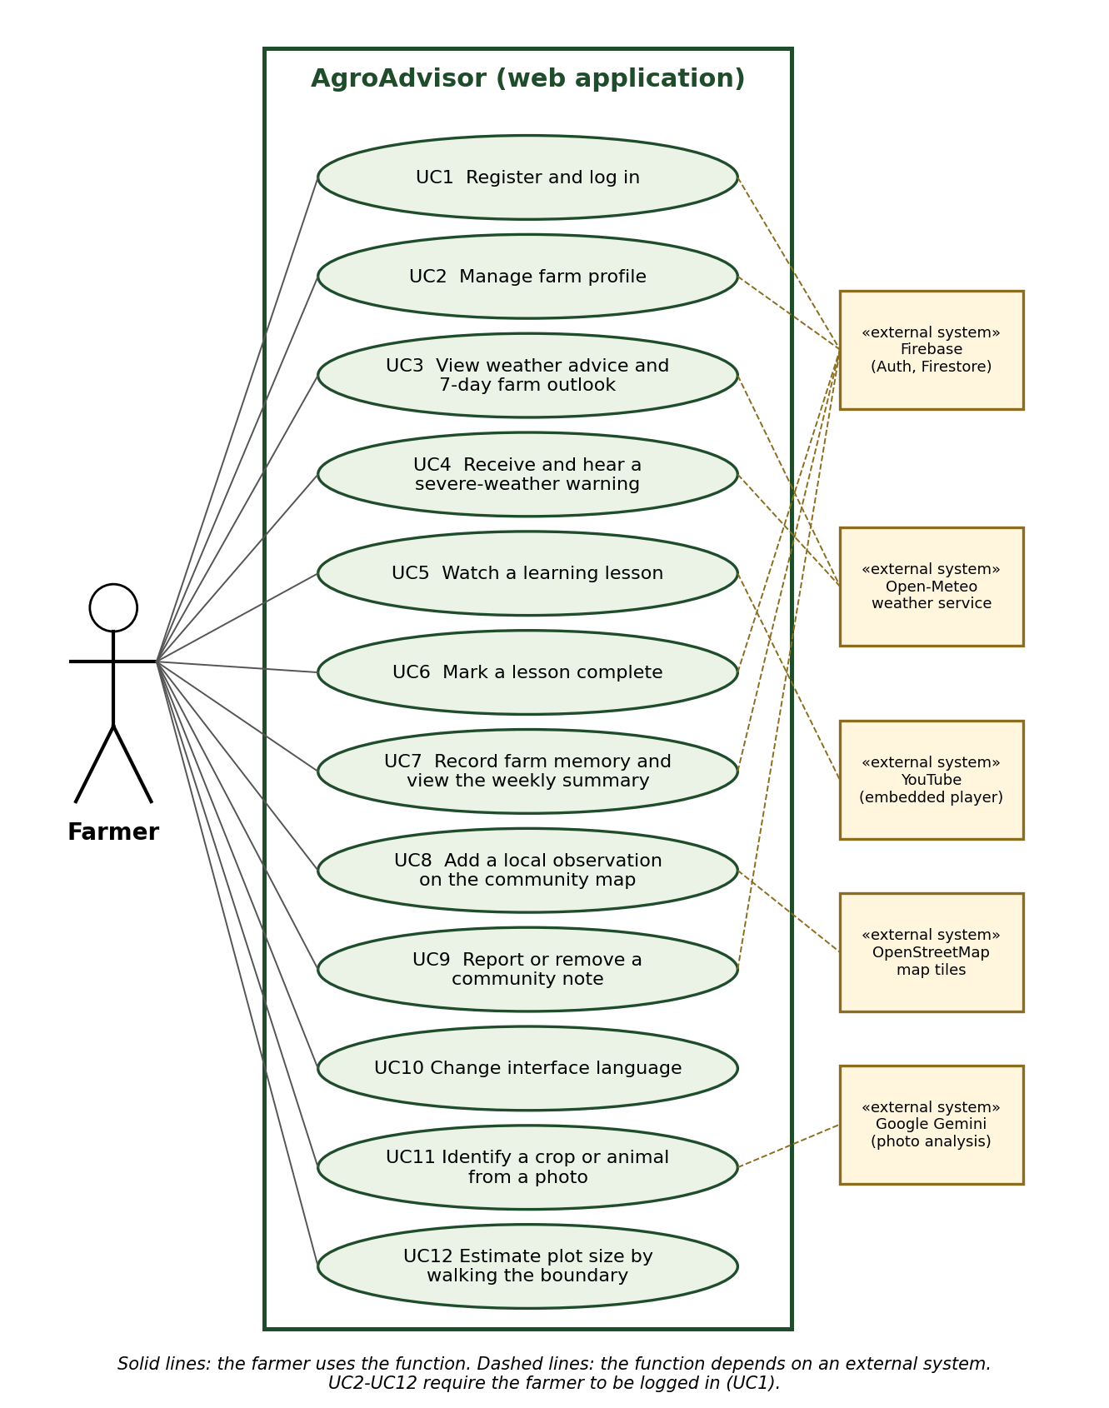
Figure 3: Use case diagram
Use case | Description | Main outcome
UC1 Register and log in | Farmer creates an account or signs in with email or Google. | Farmer reaches the dashboard.
UC2 Manage farm profile | Farmer enters or edits farm name, location, size, crops and livestock. | Advice is based on the saved profile.
UC3 View weather advice and 7-day outlook | Farmer sees current weather and a daily outlook with risk notes. | Farmer can plan the week.
UC4 Receive and hear a severe-weather warning | System shows a warning with action, timing and reason, and can read it aloud. | Farmer can protect crops and animals.
UC5 Watch a learning lesson | Farmer opens a reviewed lesson and plays the video. | Farmer learns a farm skill.
UC6 Mark a lesson complete | Farmer confirms the lesson is done. | A lesson entry is added to farm memory.
UC7 Record farm memory and view weekly summary | Farmer saves a weather, planting or success note. | Weekly counts and recent entries are updated.
UC8 Add a local observation | Farmer places a pin within 25 km of the farm with a short note. | Neighbours see the note on the map.
UC9 Report or remove a community note | Farmer reports another farmer's note, or removes their own. | Reported notes are hidden after two different reports.
UC10 Change interface language | Farmer selects one of five languages. | Screens appear in that language.
UC11 Identify a crop or animal from a photo | Farmer takes a photo and the system suggests a name. | The item can be added to the farm profile.
UC12 Estimate plot size | Farmer walks the boundary with GPS on. | Farm size field is filled in.

2.3.2 Activity diagram
The activity diagram shows the main flow of the system: from opening the dashboard to seeing advice or a severe-weather warning.
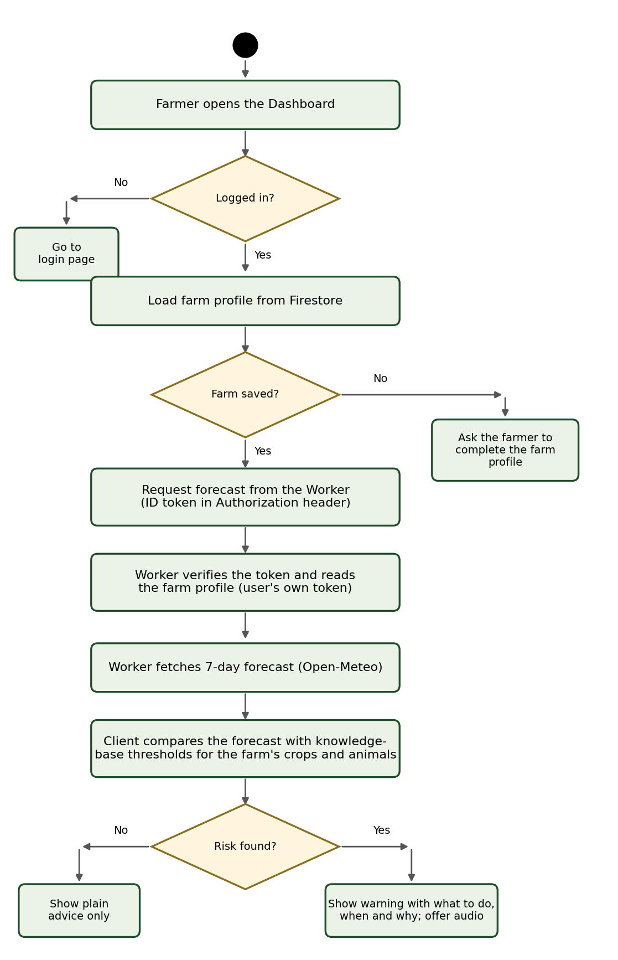
Figure 4: Activity diagram: view weather advice and warnings

2.3.3 State diagram
A community note moves through a small set of states. The rules allow a visible note to be reported only by another farmer and only once per farmer.
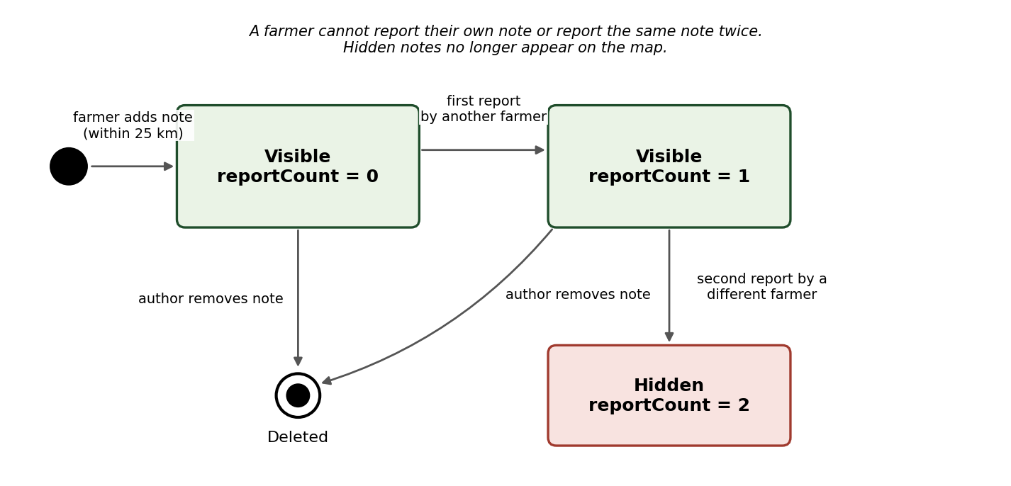
Figure 5: State diagram of a community note

2.3.4 Class diagram
The classes mirror the data stored in Firestore. The farmer and the farm share the same identifier, so a farmer has exactly one farm.
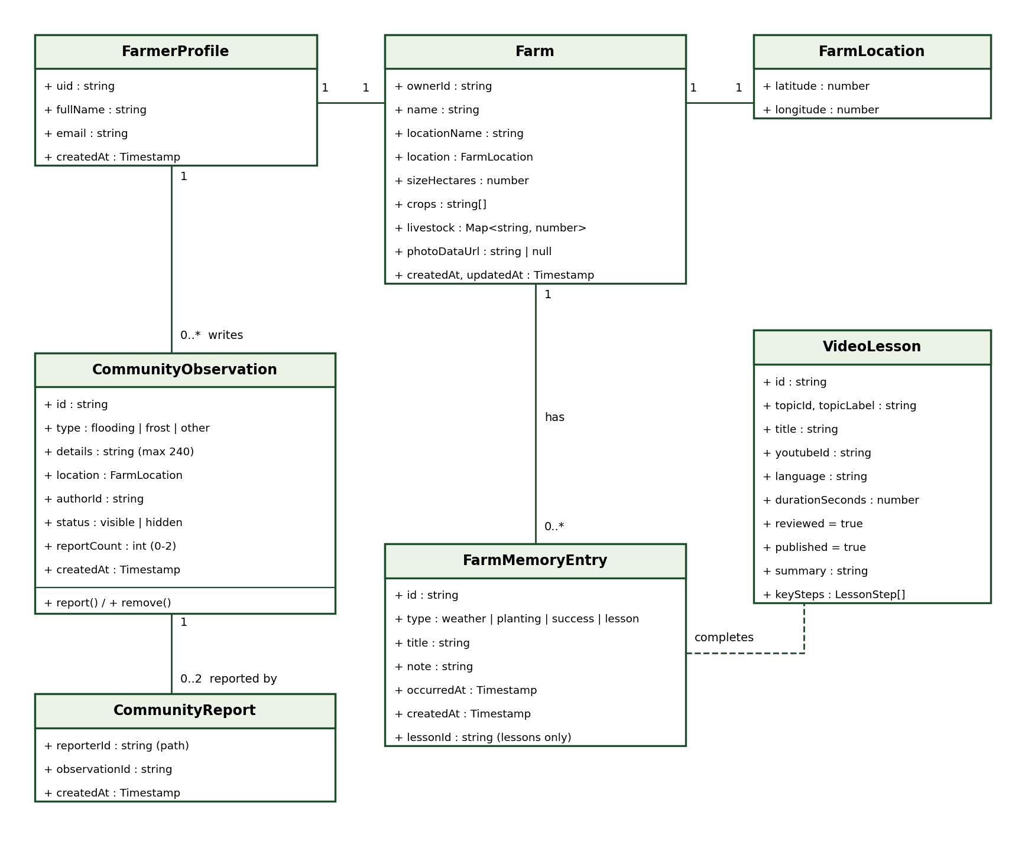
Figure 6: Class diagram

2.3.5 Sequence diagram
The sequence diagram shows how a forecast request travels through the client, the Worker, Firestore and Open-Meteo.
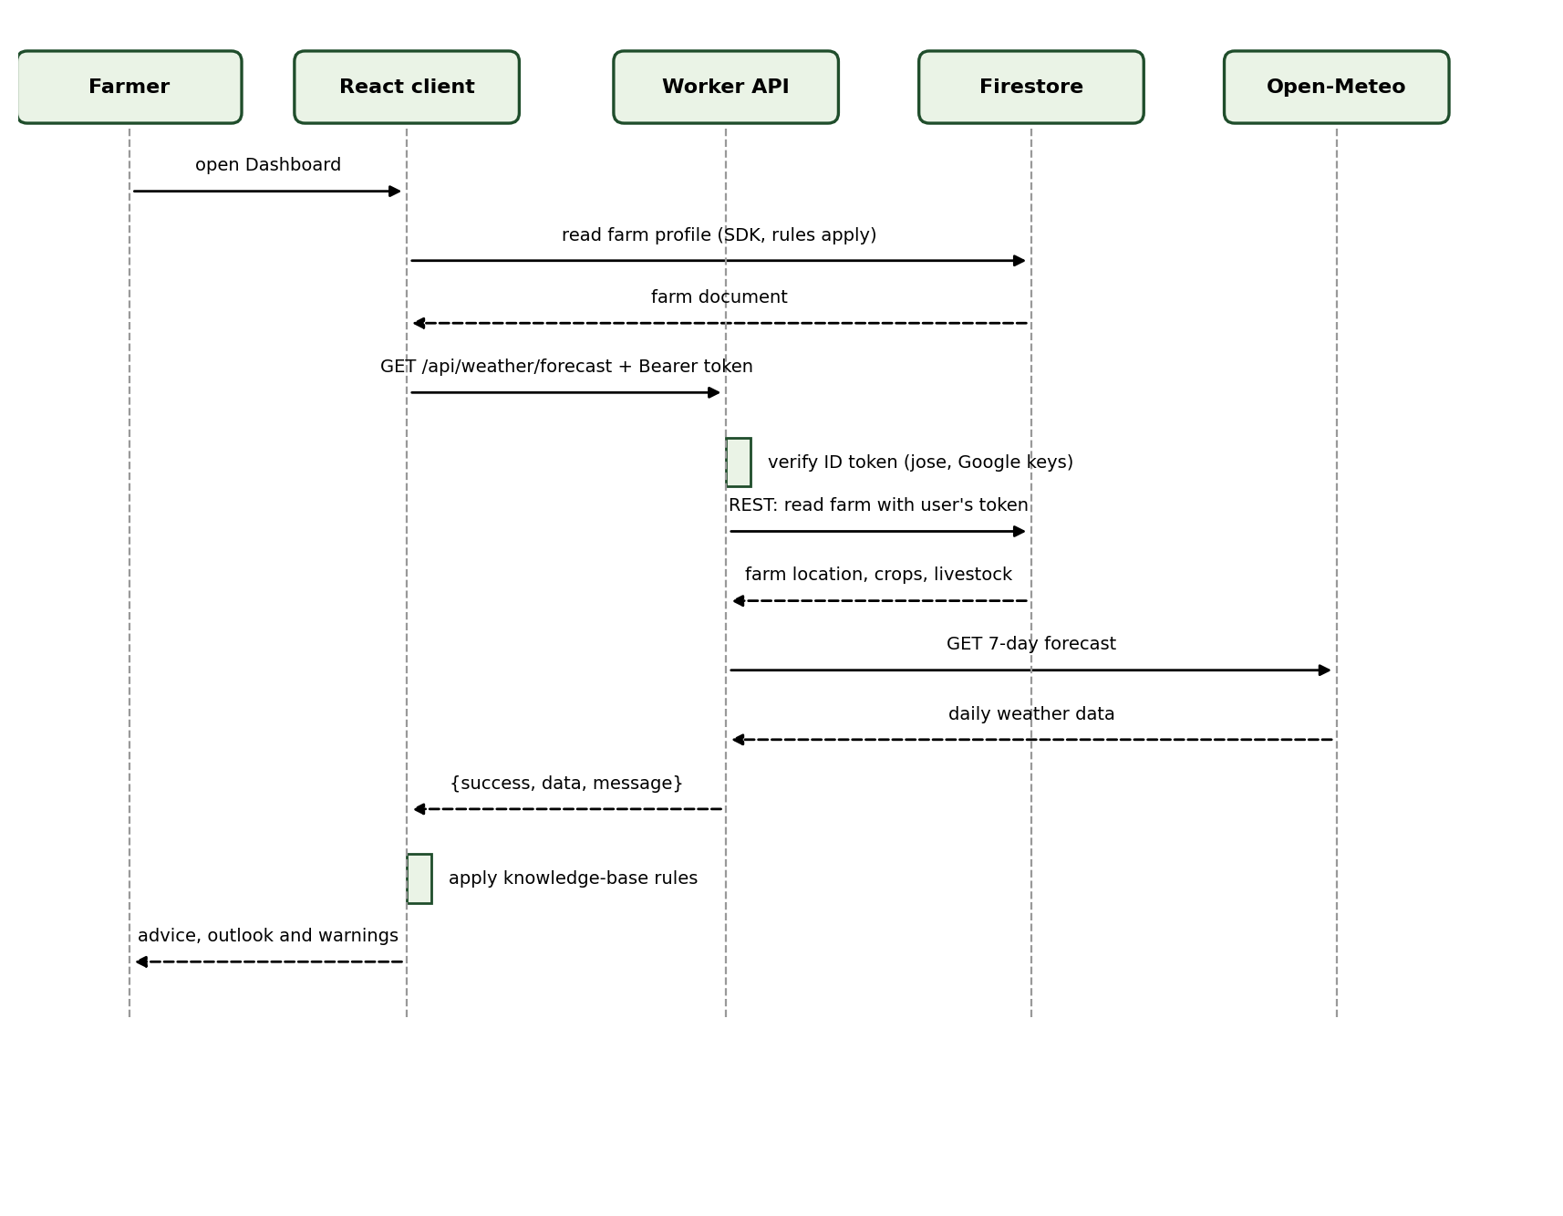
Figure 7: Sequence diagram: load farm weather advice

3. Project Management

3.1 Work breakdown
Each task lists its deliverables, milestone, resources, dependencies and constraints, and risks with contingencies. The durations are planned effort and must be replaced with the real dates of the project.

T1 Requirements and interview plan
Item | Detail
Deliverables | Interview questionnaire; list of problems; requirements list
Milestone | Phase 1 document approved
Resources needed | Student, supervisor, farmers to interview
Dependencies and constraints | None. Constraint: access to real farmers
Risks and contingencies | Risk: no farmer available. Contingency: use published sources and mark findings as unverified

T2 Design (UI, data, architecture)
Item | Detail
Deliverables | Context, architecture, use case, class, sequence, state and activity models; data design; colour theme
Milestone | Phase 2 document approved
Resources needed | Diagram tools, Figma or paper sketches
Dependencies and constraints | Depends on T1
Risks and contingencies | Risk: design changes during build. Contingency: keep the design modular and update models afterwards

T3 Authentication and farmer profile
Item | Detail
Deliverables | Register and login pages; Firebase project; farmer and farm services; farm profile form
Milestone | A farmer can register, log in and save a farm
Resources needed | Firebase Spark plan, Google sign-in setup
Dependencies and constraints | Depends on T2. Constraint: authorised domains must include the dev address
Risks and contingencies | Risk: login blocked by domain settings. Contingency: add the domain in Firebase and test email login first

T4 Weather advice and alerts
Item | Detail
Deliverables | Cloudflare Worker with forecast route; weather-advice rules; dashboard; severe-weather warning; knowledge-base file
Milestone | Dashboard shows advice and a warning for a real farm
Resources needed | Open-Meteo (free, no key), Wrangler, Hono
Dependencies and constraints | Depends on T3
Risks and contingencies | Risk: weather service outage. Contingency: clear error message and retry button

T5 Learn page and farm memory
Item | Detail
Deliverables | Lesson data and page; lesson completion; farm memory page with weekly summary
Milestone | A farmer can watch and complete a lesson and see it in memory
Resources needed | Reviewed video list, Firestore
Dependencies and constraints | Depends on T3
Risks and contingencies | Risk: unreviewed videos. Contingency: only show lessons marked reviewed and published; review videos before final submission

T6 Community map and security rules
Item | Detail
Deliverables | Community map page; add, report and remove notes; Firestore Security Rules and indexes; rule tests
Milestone | Six rule tests pass and notes can be added and reported
Resources needed | react-leaflet, OpenStreetMap, Firebase emulator, Java
Dependencies and constraints | Depends on T3 (farm location)
Risks and contingencies | Risk: query needs an index that takes minutes to build. Contingency: deploy indexes early

T7 Photo identification and speech
Item | Detail
Deliverables | Vision and speech Worker routes; photo scan in the farm form; spoken warnings
Milestone | A photo returns a crop or animal name; a warning can be played as audio
Resources needed | Google Gemini and Azure Speech keys held as Wrangler secrets
Dependencies and constraints | Depends on T4
Risks and contingencies | Risk: keys missing or quota used. Contingency: typed name entry and on-screen text still work

T8 Testing and fixes
Item | Detail
Deliverables | Type checks, build, rule tests, manual browser tests of each page; fixes
Milestone | All pages work with a real account and sample data
Resources needed | Browser, test accounts, seed data
Dependencies and constraints | Depends on T3 to T7
Risks and contingencies | Risk: late bugs. Contingency: test each module when it is finished

T9 Documentation
Item | Detail
Deliverables | Phase 1, Phase 2, Phase 3 and final report
Milestone | Each document handed in on time
Resources needed | Word, diagram scripts, screenshots
Dependencies and constraints | Runs alongside T1 to T8
Risks and contingencies | Risk: documents fall behind the system. Contingency: update documents at each milestone

T10 Deployment and final review
Item | Detail
Deliverables | Client on Cloudflare Pages; Worker deployed; final demonstration
Milestone | System live and demonstrated
Resources needed | Cloudflare account, Wrangler, Firebase deploy
Dependencies and constraints | Depends on T8
Risks and contingencies | Risk: environment differences. Contingency: test the deployed build with a fresh account

3.2 Gantt chart
The chart shows the planned order and overlap of the tasks in project weeks. [Replace the week numbers with calendar dates agreed with the supervisor.]
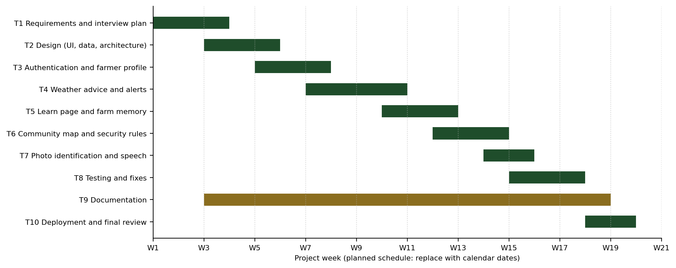
Figure 8: Gantt chart (planned schedule)

4. Conclusion
This document defines what AgroAdvisor must do and how it is built. The functional and non-functional requirements, the models and the work plan describe one system: a farmer-only advisory platform that turns weather data and the farm profile into advice and warnings. The one planned feature that is not yet built is background push notification (FR17).

